

**Fruits VN**

|  |  |  |
| --- | --- | --- |
| **Supervisor:** | *LÊ THANH NHÂN* | |
| **Semester:** | *II* | |
| **Batch No:** | *T1.2011.M0* | |
| **Group No:** | *03* | |
| **Order:** | **Full name** | **Roll No.** |
| *1.* | *Đỗ Trần Long* | *Student1287966* |
| *2.* | *Lê Ngân Tâm* | *Student1288146* |
| *3.* | *Hà Vĩnh Kiện* | *Student1273022* |
| *4.* | *Trương Lê Thiện Quang* | *Student1280925* |

***Month****: 9* ***Year****: 2021*

This is to certify that

|  |  |
| --- | --- |
| **Mr.** | **Do Tran Long** |
| **Ms.** | **Le Ngan Tam** |
| **Mr.** | **Ha Vinh Kien** |
| **Mr.** | **Truong Le Thien Quang** |

Have successfully Designed & Developed

|  |  |  |
| --- | --- | --- |
|  |  |  |
| **Fruits VN** | | |

Submitted by:

|  |
| --- |
| **Mr. LE THANH NHAN** |

Date of Issue:

|  |  |
| --- | --- |
|  |  |

Authorized Signature:

**CONTENT**

Contents Page 3

Acknowledge Page 4

Summary Page 5

Review 01 Page 6

Review 02 Page 12

Review 03………………………………………………..Page 20

Testing Document Page 24

Final CheckList Page 25

Tasksheet Page 27

**Acknowledge**

As we understand that the Project is a step-by-step learning enviroment that closely simlutales the class-room and Lab based learning enviroment into actual implementation. It is projectimplementation at your fingertips! An electronic, live juncture on the machine that allows you to.

* Practice step by step i.e laddered approach.
* Build a larger more robust application.
* Usage os certain utilities in applications designed by usser.
* Single program to unified code leading to a complete application.
* Learn implementation of concepts in phased manner.
* Enhance skills and add value.
* Work on real life projects.
* Give a real life scenario and help t create application more complicated and ueseful.
* Mentoring through email support.

We thank you all others student for the supports in this project. And a special thank you Mr. Le Thanh Nhan, instructor knowledge and encourage us in this project, he is always ready to help đỡn when we hard.

Beside serveral mistakes we had made in the project, we hope to have more oppotunities to widen our knownledge in web developing world.

We also thank you so much for your infomation and the "demo" project from India APTECH to help us get more reality experience in this project. Since we have gained more experience from this project, we will not stop learning any thing as much as we can to be more successful in the future.

Your sincerely.

Team Group 03.

**Synposis**

The Object of this program re aim is to give a sample project to work on real life projects. These applications help us build a larger more robust application.

The objecttive is not to teach us front-end or back-end technology but to provide us woth a real life scenario and helps us create basic applications using the tools.

Hence, we can revise the chapters before we start with the project.

This project is meant for students like us who have completed the module of Semester II, as well as special subjects those are Java and PHP. These propgrams should be done in the Lab sessions with assistance of the faculty if required.

In which, we do theme Fruits VN to create web and the experience of it. web design is the preferred choice for clean fruit suppliers to promote their products, in line with the global general trend. Professional Vietnamese fruit web design will help businesses get closer to a huge customer base and break through revenue.

It is very essential for us that will have a clear understanding of the subject. We think we should go through the project amd solve the assignments as per requirements given.

Honest, straightforward in all information, products we bring. Confident, creative, constantly learning, always listening and ready to bring the best experiences to our customers and friends and partners.

**REVIEW 01**

**Problem Defnition**

Company Fruit VN specializes in providing fruit VietNam. Fruit side general I've always fresh and cool. Our products are very popular in domestic and international. We are always ready to meet the needs of customers. A solution that we should have a website of its own to provide product information and buy and sell on the web easier.

Based on the need stated in the Project Overall, we design an application that will provide the key features and functionalities as the followings:

✓ Provide function for member register.

✓ Provide information of the product to customers and members,

✓ Provide shopping cart fimction so customers and members can order products.

✓ The member can take their privacy through Member Control Panel (MCP)

✓ Receive comments from customers and members to improve service quality as well as product quality.

An Admin Control Panel (ACP) that support about management system:

✓ Administrators the ability to add, update product information quickly and accurately.

✓ Administrators the ability to manage members and their feebback, comment or rating.

✓ Adhninistrators the ability to manage delivery progress belong to orders.

✓ Administrators the ability report statistics,

The Role of User and Admin:

1. User:

✓ Can register as a member and manage personal account.

✓ Can view and buy products.

✓ Can give feedback, comment, rate about products.

✓ Can view their orders.

2. Administrator:

✓ Can add / edit / deactivate products and categories.

✓ Can view customer's information or deactivate an account.

**Customer Requirements Specificationsc**

Describe the points in the processing cycle data for each object use

**User:**

**Input:**

- Member registration information.

- View product's information.

- Order selected products.

- Feedback about products.

**Process:**

- Search products from database by categories, by product types.

- Process customer registration information

- Process product's feedback.

- Process customer orders.

**Output:**

- Notification of successful registration / failure.

- Product information.

- Notification of successful making order order.

**Webmaster:**

**Input:**

- Administrator login information.

- Product and category information to add / edit / delete.

- Member information to be search delete.

- Order information to be search / approve.

**Output:**

- Add / edit / delete products.

- View information of all members.

- Change member account's status.

- View all orders.

- Update order status.

**Process:**

- Notification to add / edit / delete products success / failure.

- Notification to change member account's status.

- Notification to update order's status.

**Hardware / software requirement**

|  |  |  |
| --- | --- | --- |
| **Sr.** | **Item** | **Description** |
| 1. | Operating synstem | Window 7, 8 or higher |
| 2. | Hardware | CPU Cores or better with 2 Gigabytes of RAM or better |
| 3. | Web Browser | Version in later of: Edge, Firefox, Chorme, etc… |
| 4. | Fonts | Standard font Unicode: Arial, Tahoma, Lucida Console, Times New Roman, etc… |
| 5. | Other requirement | NodeJS, Git, XAMPP 7.3 or later | A working internet connection. |

**Review 02**

**Data Flow Diagram**

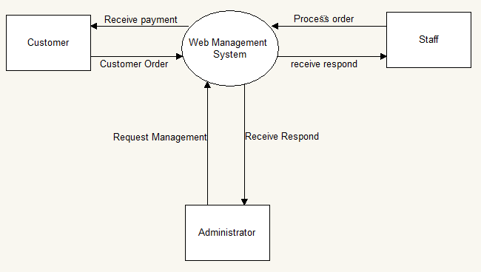

**Entity Relationship Diagram**

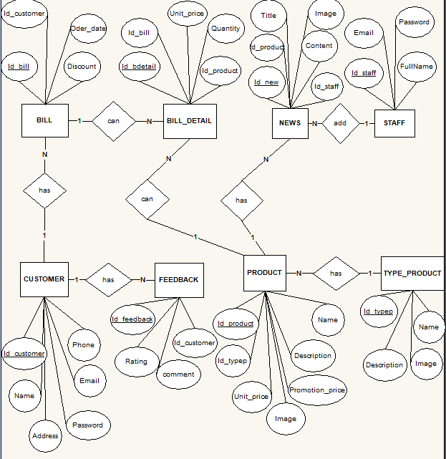

1. **Table Design**

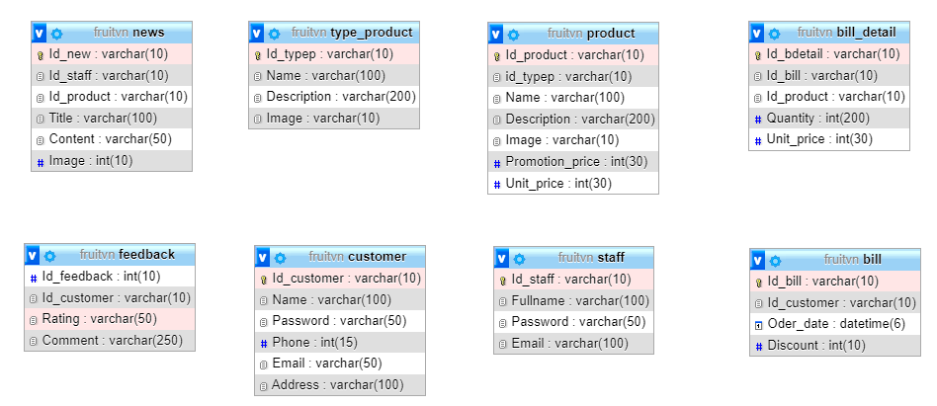

1. **Relationship Diagram**

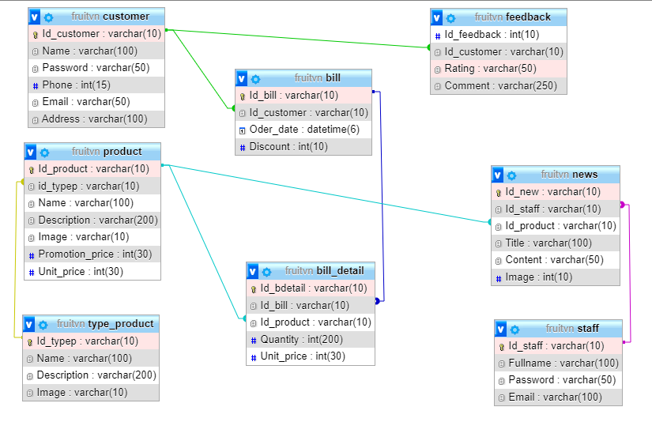

**SiteMap**

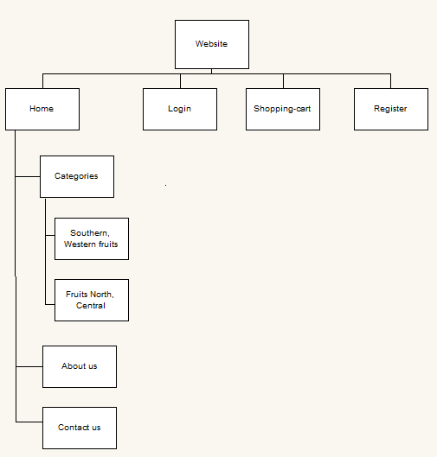

1. **Admin**

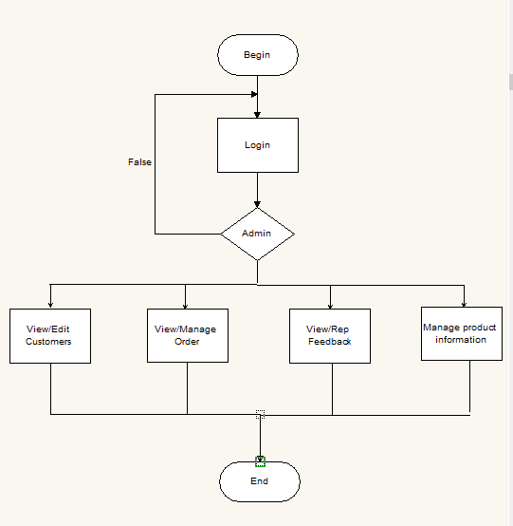

1. **Staff**

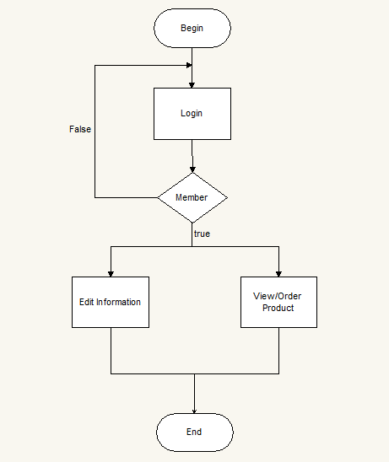

1. **Customer**

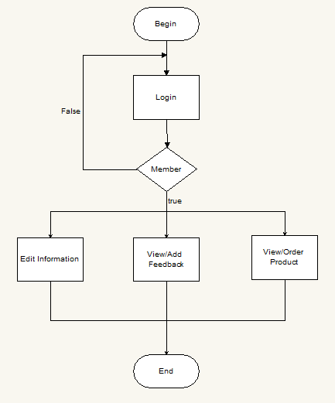

**Review 03**

**Screen shots**

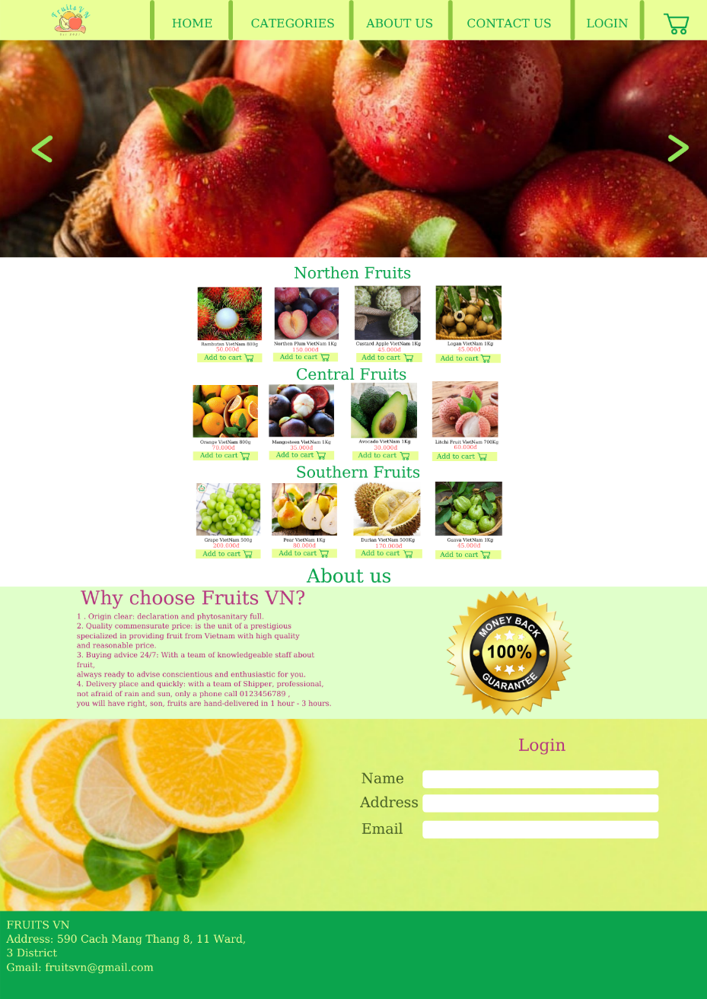

**Description : Wes Fruits VN sells fruit online. Use to purchase and order fruits on this website.**

**From : Open from the homepage. Fruit web menu.**

**To : Can go to About us page.**

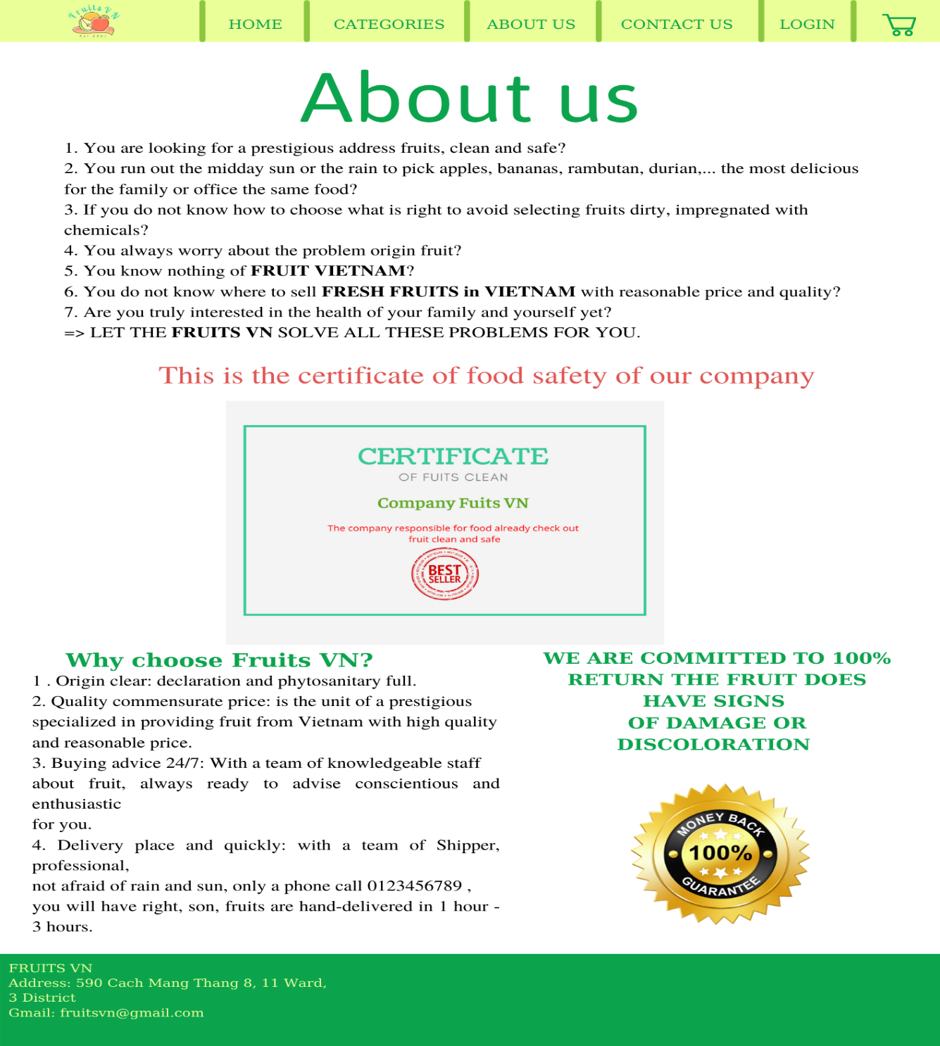

**Description : Wes Fruits VN sells fruit online. Use to purchase and order fuitts on this website.**

**From : Open from the About us. About the website and successful criteria**

**To : Can go to About us page.**

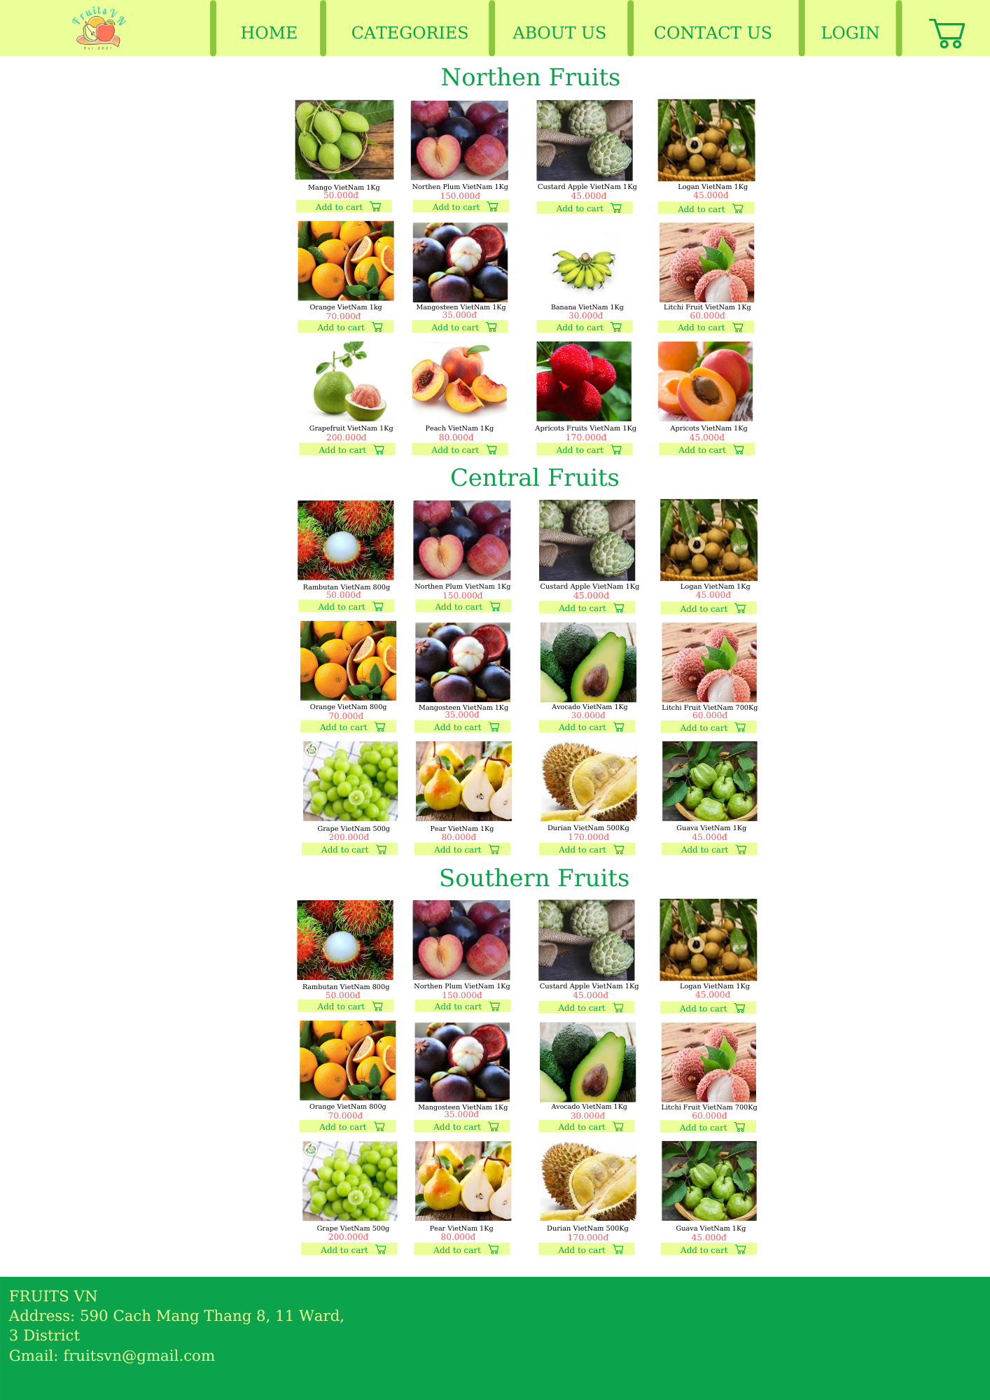

**Description : Wes Fruits VN sells fruit online.** **Page dividing the domains of Vietnamese fruits.**

**From : Open from the About us. Fruit categories site of the domain**

**To : Can go to About us page.**

**Testing document**

|  |  |  |
| --- | --- | --- |
| **Sr.No** | **Features Tested** | **Remarks** |
| 1 |  |  |
| 2 |  |  |
| 3 |  |  |
| 4 |  |  |
| 5 |  |  |
| 6 |  |  |
| 7 |  |  |
| 8 |  |  |
| 9 |  |  |
| 10 |  |  |
| 11 |  |  |
| 12 |  |  |
| 13 |  |  |
| 14 |  |  |
| 15 |  |  |

**Final checklist**

|  |  |  |
| --- | --- | --- |
| **Sr.No** | **Aspected Tested** | **Suggestion/**  **Remaks** |
| 1 | Are all the users table to view the images and links? |  |
| 2 | Have all the views , modules and controllers been property integrated and is the site function as a single page application? |  |
| 3 | Are the GUI content devoid of spelling mistakes? |  |
| 4 | Is the application user-friendly? |  |
| 5 | Is the Website launching correctly in all popular browsers? |  |
| 6 | Are all the forms validated with proper criteria? |  |
| 7 | Do all text links lead to the appropriate website? |  |
| 8 | Do all image links lead to the appropriate website? |  |
| 9 | Are all the images and links clearly visible on the page? |  |
| 10 | Does the Web page work properly in all the tested browsers? |  |
| 11 | Does the Web page take too long to be loaded fully? |  |
| 12 | Is the navigation sequences correct through all the Web pages on the site? |  |
| 13 | Is the JavaScript code working as expected in all click events? |  |
|  |  |  |
|  |  |  |

|  |  |  |  |  |  |  |  |  |
| --- | --- | --- | --- | --- | --- | --- | --- | --- |
| **No** | **Member** | **Contents** | | **Table Name** | **Activity Plan** | **Date of Preparation of Activity Plan** | | |
| **Planed Start Date** | **Actual Start Date** | **Actual Days** | **Status** |
| 1 | **ĐỖ TRẦN LONG** | Admin | *Staff,New Management* | Staff/News | 5/10/2021 | 9/25/2021 | 21 | OK |
| 2 | 5/10/2021 | 9/25/2021 | 21 | OK |
| 3 | Staff | *Login Staff* | 5/10/2021 | 9/25/2021 | 21 | OK |
| 4 | *Staff(Order , View);New(Add , Edit)* | 5/10/2021 | 9/25/2021 | 21 | OK |
|  |  |  |  |  |  |  |  |  |
| 1 | **LÊ NGÂN TÂM** | Admin | *Product/Type_Product Management* | Product/Type_Product | 5/10/2021 | 9/25/2021 | 21 | OK |
| 2 | 5/10/2021 | 9/25/2021 | 21 | OK |
| 3 | 5/10/2021 | 9/25/2021 | 21 | OK |
| 4 | Staff/  Customer | *View,Add Product/Type_Product* | 5/10/2021 | 9/25/2021 | 21 | OK |
|  |  |  |  |  |  |  |  |  |
| 1 | **HÀ VĨNH KIỆN** | Admin | *Customer Management* | Customer | 5/10/2021 | 9/25/2021 | 21 | OK |
| 2 | 5/10/2021 | 9/25/2021 | 21 | OK |
| 3 | Customer | *Register* | 5/10/2021 | 9/25/2021 | 21 | OK |
| 4 | *Account management, Order/View* | 5/10/2021 | 9/25/2021 | 21 | OK |
|  |  |  |  |  |  |  |  |  |
| 1 | **TRƯƠNG LÊ THIỆN QUANG** | Admin | *Bill/Bill_Detail Management* | Bill/Bill_Detail | 5/10/2021 | 9/25/2021 | 21 | OK |
| 2 | 5/10/2021 | 9/25/2021 | 21 | OK |
| 3 | Staff | *Send Bill* | 5/10/2021 | 9/25/2021 | 21 | OK |
| 4 | *Personal Bill Management* | 5/10/2021 | 9/25/2021 | 21 | OK |